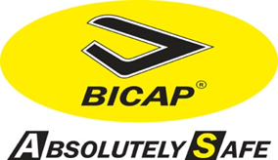 |  | PRODUCT SPECIFICATION |  | ARTICLE  OS5345-3B S3 BLACK
Article OS5345-3B S3  Weight 1,120 Kg SIZE 42  Color BLACK |  | Description of the article: safety shoe, ankle model, full grain leather, lining CAMBRELLA, double density outsole in Pu, steel toe cap toecap and steel midsole. |  | SECURITY CATEGORY  S3SRC
TECHNICAL DETAILS |  |  | IMAGE
Type of PPE | Safety shoe for professional use in compliance with low EN ISO 20345:2011 |  | 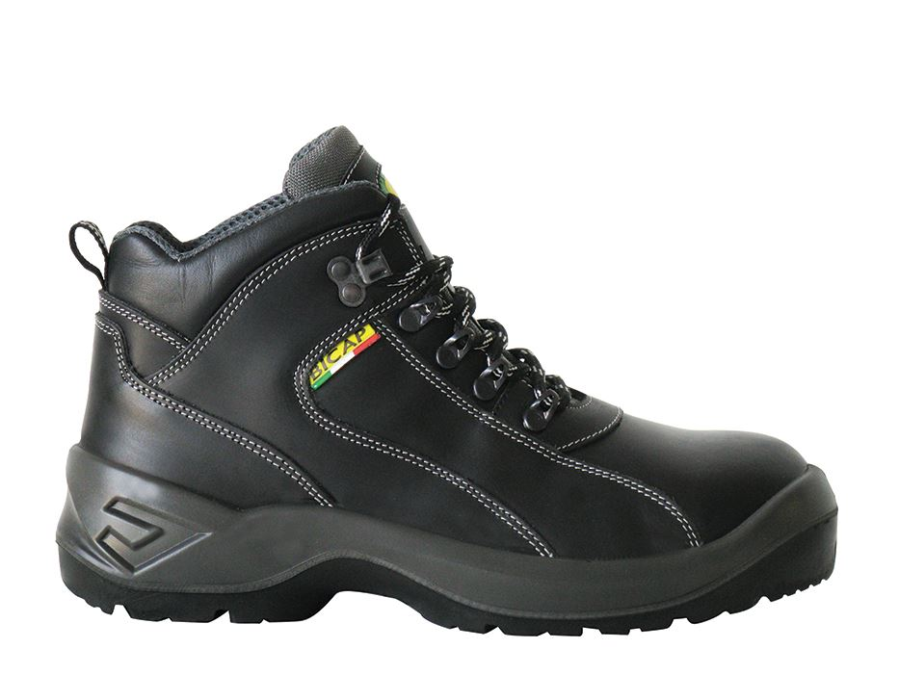
Main features | Black anklemodel of safety shoe in printed leather,  Double layer sole in soft latex, antistatic, anti bacterial with SANITIZED treatment, lined in breathable and high scratch resistant fabric.  Mesh Cambrella lining, good breathable.  grey stitching.  Black-grey laces  Steel toecap, resistant up to 200 J.  Steel midsole,.  Test results: resistance improved more than 20% to nail's Perforation (diameter 4,5mm) comparable to a strength of 1360 N instead of 1100 N requested by EN 12568.  Double density outsole, antistatic, anti spilt, resistant to oil spilt and, injected on the upper.  - First injection in PU of grey color. Shock absorber main features.  - Land outsole very resistant in PU..
Security category | S3
Law | CE UNI EN ISO20345:2011 – SAFETY SHOES
Main features | UNI EN ISO 20345:2011 – Safety shoe with toe capacity resistance up to 200 J  ENV 13287:2000 – Anti slip resistance  Directive 1907/2006/CE – Determination of dangerous substances for leather and fabric elements.  Directive 1907/2006/CE – Determination of the level of nickel for the metal parts in contact with the foot.
 | This safety shoe S3SRC is in compliance with the law EN 20345:2011
Manufactured by | CALZATURIFICIO 5BI-ITALY

